Unit 6– Probability
Independent Events

By the end of this lesson you will be able to ____________________________________________________.

What is Probability?______________________________________________________________________.
What three ways can probability can be represented?

1) _____________________ 2) ______________________ 3) ____________________

What values represent Certain? _______ _______ _______
What values represent As Likely As Not? _______ _______ _______
What values represent Impossible? _______ _______ _______

What are independent events? ______________________________________________________________.
How is rolling a die an independent event?

How is flipping a coin an independent event?

Example 1: Using an Area Model
What is the probability that you can roll a ______ on a die and flip ________ up on a coin?
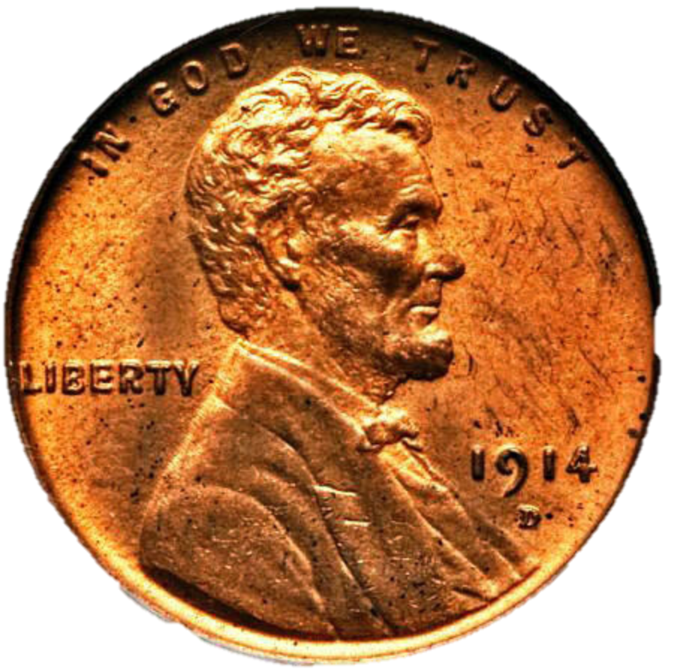
What is the ratio we use for probability?
____________________________________________

Outcomes for the 2nd event
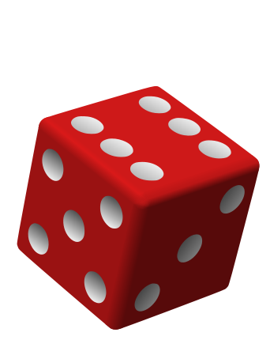
What is the probability of the events occurring together?
As a fraction? ____________________
As a decimal? ____________________
As a percent? ____________________

How many outcomes do the two events have together?

Outcomes for the 1st event

Example 2: Using Multiplication
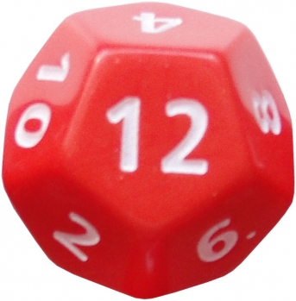
What is the probability that you can flip ___________ up on a coin and roll a _______ on a 12-sided die?
Outcomes for the 2nd event
Outcomes for the 1st event

What is the probability for the first event to occur? ____________ 2nd Event to occur? ___________
What operation will you use to determine the probability of these events occurring together? ________
What is the probability for these events to occur together?
As a fraction? _________ As a decimal? _________ As a percent? ________

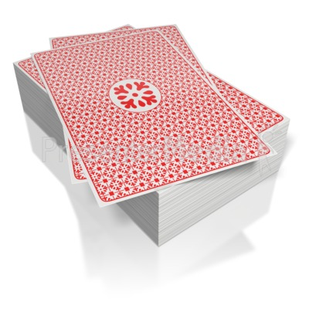
Example 3: With Replacement
What is the probability that you can pick a red card put it back in the deck and pick the black card?
What is the probability for the first event to occur? ____________ 2nd Event to occur? ___________
What operation will you use to determine the probability of these events occurring together? ________
What is the probability for these events to occur together?
As a fraction? _________ As a decimal? _________ As a percent? ________

Example 4: With Replacement
What is the probability that you can pick the Ace of Hearts, put it back in the deck, and pick the King of Clubs?
What is the probability for the first event to occur? ____________ 2nd Event to occur? ___________
What operation will you use to determine the probability of these events occurring together? ________
What is the probability for these events to occur together?
As a fraction? _________ As a decimal? _________ As a percent? ________
Math 7 Unit – Probability
Your Turn to Practice. [fill in the missing information for each problem using the video]
Find the probability of the events. Write as a fraction, decimal and a percent. Round to the nearest thousandths when necessary.
- Probability of rolling an _______ number on a standard die and flipping a _________.

- Probability of choosing two vowels, with replacement, from the word ___________________.

- Probability of picking an _______ number, putting it back, and then picking a multiple of _____, from the numbers ____________.

- Probability of rolling a die three times, all coming up _________ numbers.

- Probability of picking a red gumball, replace it and then choose a blue gumball, from ______ red and ______ blue gumballs.

