Unit 6– Probability
Dependent Events

By the end of this lesson you will be able to _____________________________________________________.
What are dependent events? ________________________________________________________________.
How does a gumball machine help explain dependent events?

Example 1: Without Replacement
What is the probability that you can get two red gumballs from the machine?
Probability for the 2nd event
Probability for the 1st event
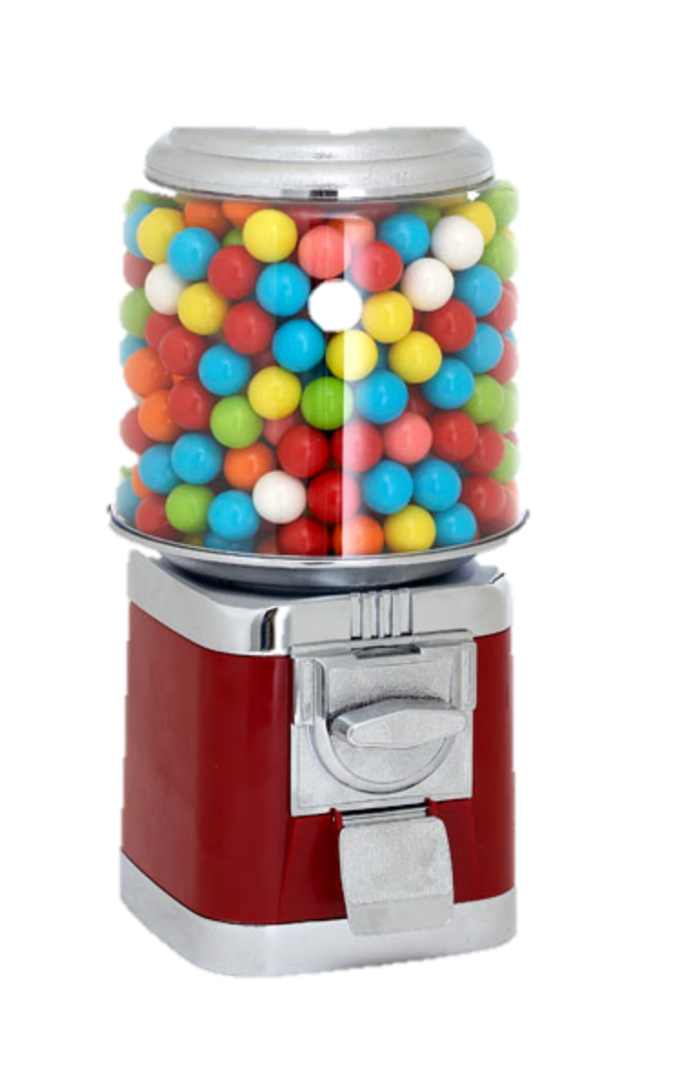
_____blue
_____yellow
_____pink
_____red
_____green
______white
________Total

How did you determine the probability for the 1st event?

How did you determine the probability for the 2nd event?

What is the probability for these events to occur together?
As a fraction? _________ As a decimal? _________ As a percent? ________

Example 2: Without Replacement
What is the probability that you can get the red gumball and then the blue gumball?
Probability for the 2nd event
Probability for the 1st event
How did you determine the probability for the 1st event?

How did you determine the probability for the 2nd event?

What is the probability for these events to occur together?
As a fraction? _________ As a decimal? _________ As a percent? ________
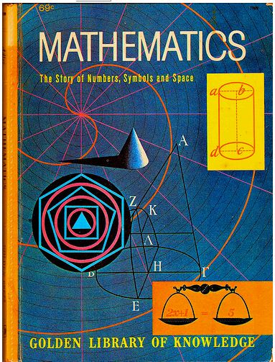
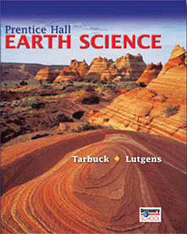
Example 3: Without Replacement
You have four homework assignments to complete in each of your core classes. What is the probability that you will choose to complete your math homework first and your science homework second?
Probability for the 1st event
Probability for the 2nd event

How did you determine the probability for the 1st event?

How did you determine the probability for the 2nd event?

What is the probability for these events to occur together
As a fraction? _________ As a decimal? _________ As a percent? ________

Example 4: Without Replacement
Two girls and a boy are taking a test. What is the probability that they will finish in the order girl, boy, girl?
Probability for the 3rd event
Probability for the 2nd event
Probability for the 1st event

How did you determine the probability for the 1st event?
How did you determine the probability for the 2nd event?
How did you determine the probability for the 3rd event?

What is the probability for these events to occur together?
As a fraction? _________ As a decimal? _________ As a percent? ________

Your Turn to Practice. [Fill in the missing information for each problem using the video.]
Find the probability of the events. Write as a fraction, decimal and a percent. Round to the nearest thousandth.
- Probability of choosing two vowels, without replacement, from the word ___________________.

- Probability of picking an odd number, not putting it back, and then picking a multiple of 10, from the numbers _____________.

- Probability of picking two red gumballs, without replacement, from _________ red and _______ blue.

- _____ boys and _____ girls are running in a race. What is the probability that the order of finishers will be in the order of ______________________________?

